1 introduction :
This is a functioning library database system this will be beneficial for every user using the database as it is purposed to explain the system in details and what is the meaning of every step took in creating this database

This documentation contains all tables and views and procedures as well as every user created for the database and the flowchart and data flow diagrams as well as the interfaces generated to help with ease of using this database and they are all tested in this report as well as steps for backing up and recovering this database as well as an overall evaluation of the system and suggested improvments

2.1
Physical schema
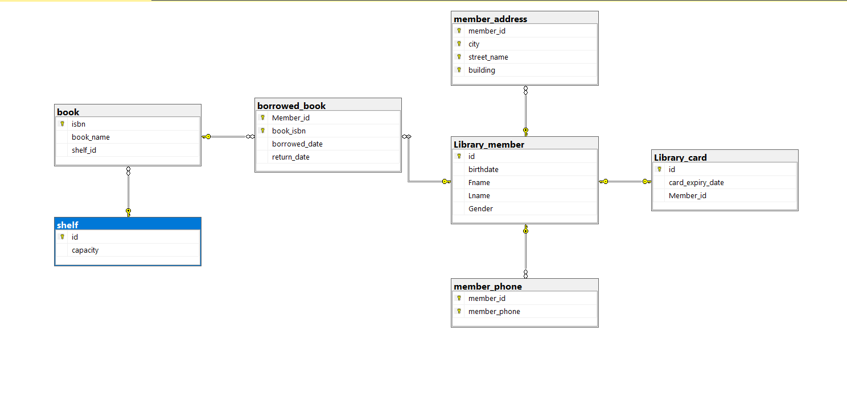

3.1
Tables created:

table | name | description
1. | book | This table contains the information for the book in the database which are  -isbn INT (primary key)  -Book name varchar 25 constraint not null  Also it has a foreign key from the shelf table called  Shelf_id INT which has the constraint not null which represents the shelf the book is placed on
2. | Library member | This table contains the information for the library members which are  -id INT (primary key)  -birthdate DATE  -Fname varchar(25)  -Lname varchar(25)  -gender char(1) which can either be F or m  And all these non prime attributes have a not null constraint
3. | Library card | This table contains the information for the library cards issued to each member as each member can only have one card  Attributes  -id INT (primary key)  -card expiry date DATE (not null)  Also it has the member id attribute which is a foreign key from the library_member table also it is unique as they cant have more than one card
4. | Member_address | This table contains the addresses for the library_members as members can have more than one address  Note :all attributes are primary  -member_id int (FK from library_member table)  -city varchar(25)  -street_name varchar(25)  -building varchar(25)
5. | member_phones | This tables stores the phone numbers o library members  Note :all attributes are primary  -member_id int (FK from library_member table)  Member_phone INT
6. | Shelf | This table contains the information for the shelf in which the books are placed at  Attributes:  -id int (primary key)  - capacity int (not null)
7 | Borrowed books | This table stores the information of the borrowed books  Attributes :  - member_id (PK AND FK from the library_member table)  -book_isbn((PK AND FK from the book table)  - borrowed_date DATE not null  -return_date DATE not null

Views created

view | name | description
1. | borrowedbooks | This view shows the borrowed books information in addition to the book name and the borrower name
2. | Member contact info | This view shows the member name and id and city and their full address and their phone number
3. | Library cards | This view shows the card id with the member name as well as the card expiry date
4. | MemberBorrowingHistory | This view shows a member’s borrowing history as it shows the member’s name and the book isbn and name and the borrowing borrow and return date

Procedures created :

procedure | name | description
1. | RenewLibraryCard | This procedure extended the library card expiry date
2. | UpdateBookShelf | This procedure changes te shelf in which the book is placed on
3. | AddMemberPhone | This procedure adds a phone number to an existing member
4. | AddMemberAddress | This procedure adds an address to an existing member

Users created:

User name | Privilege command | description
Administrator | Select,insert,update,delete on all tables | This is the database administrator in which he can perform all tasks on the database as he is the responsible for creating the database
Book_manager | Select ,insert,update,delete on book table | This is the book manager which is responsible for the books in the library they can perform all tasks on books table
It_support | Select on all tables | The it support can read what is in the tables for troubleshooting purposes

Screenshots :

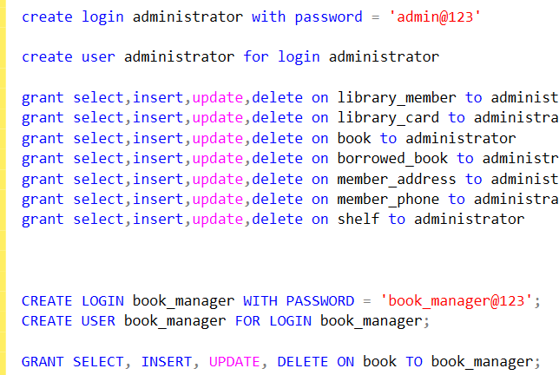

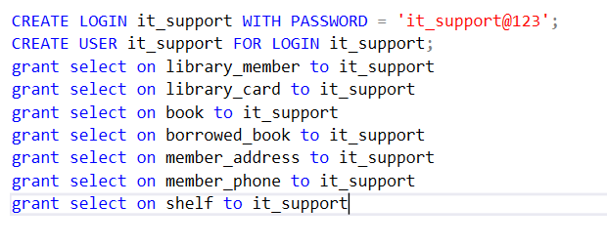

3.31

DFD for book_manager
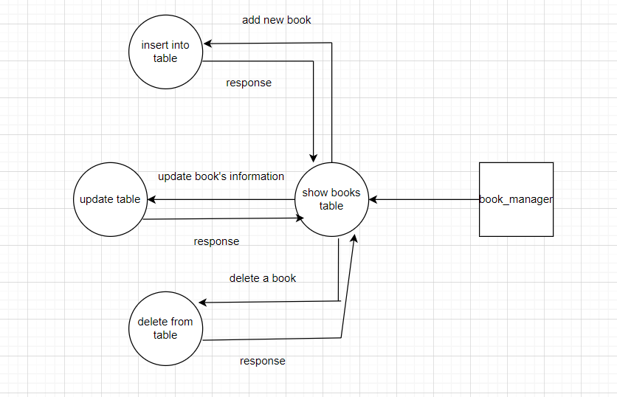

DFD for it_support

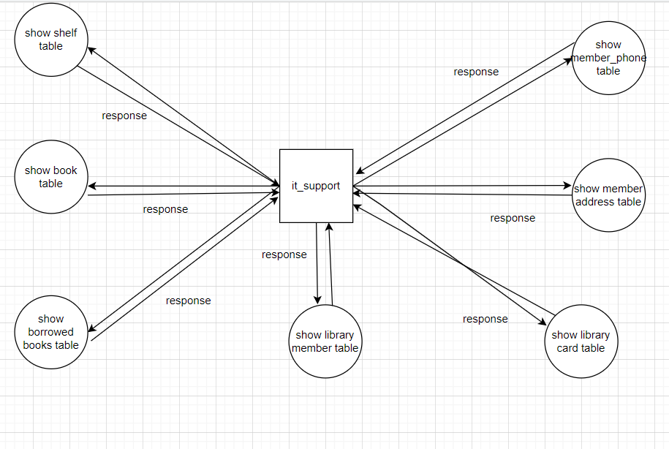

Flowchart for admin:
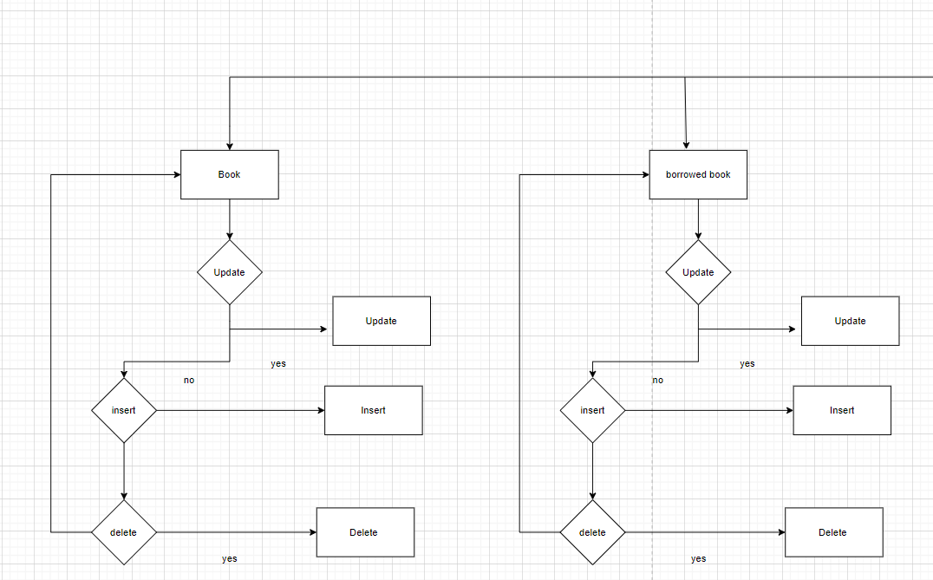
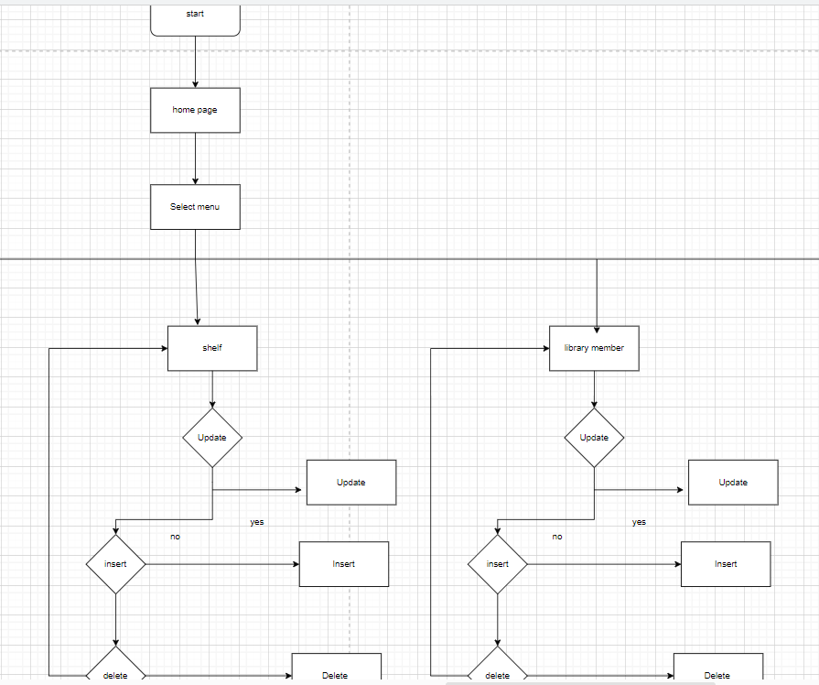
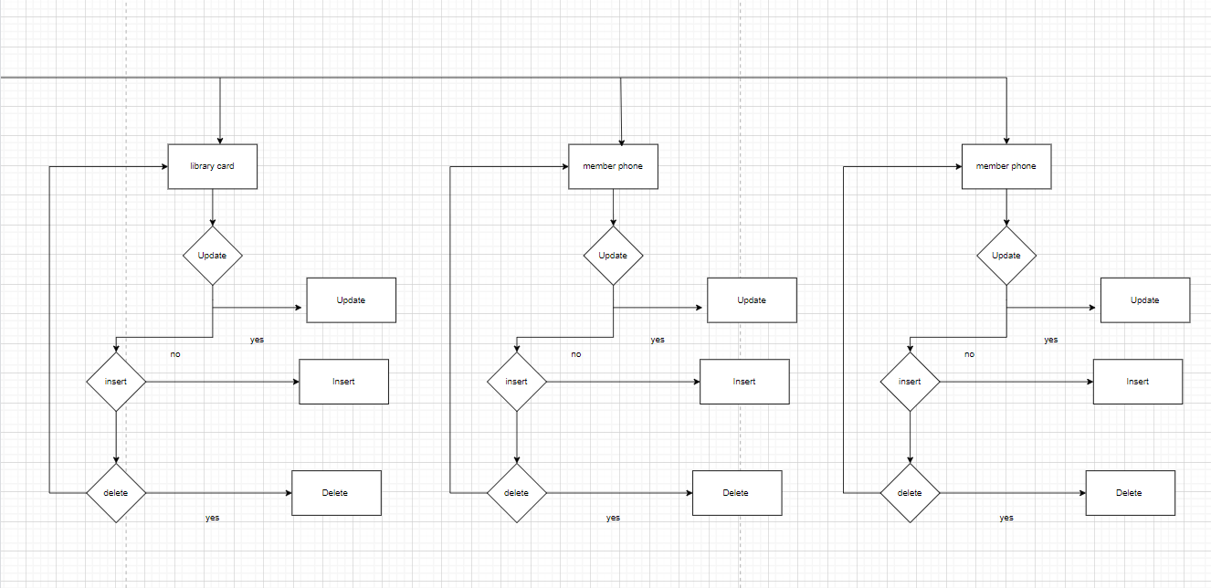

3.3.2
GUI pages generated:

Page id | Title | Description
1 | Borrowed book for it support | The it support user can only read data from this page
2 | Library card for it support | The it support user can only read data from this page
3 | Library member for it support | The it support user can only read data from this page
4 | Member phone for it support | The it support user can only read data from this page
5 | Book for it support | The it support user can only read data from this page

Screenshots :
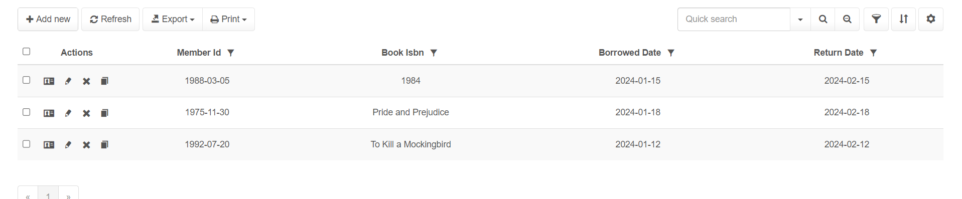
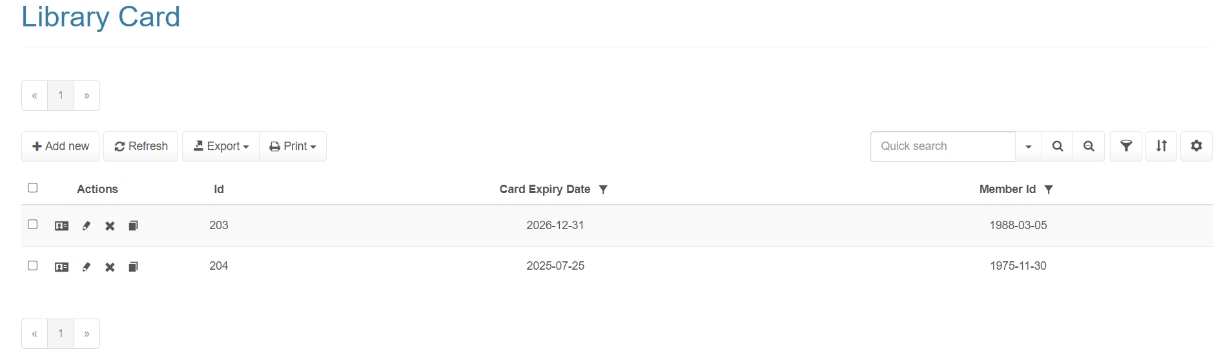

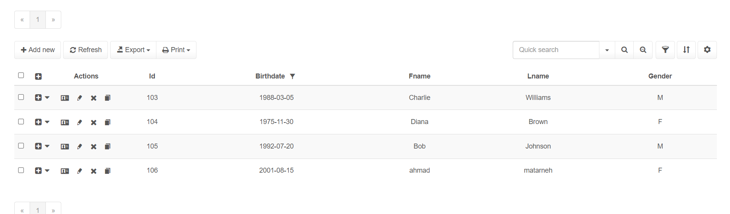

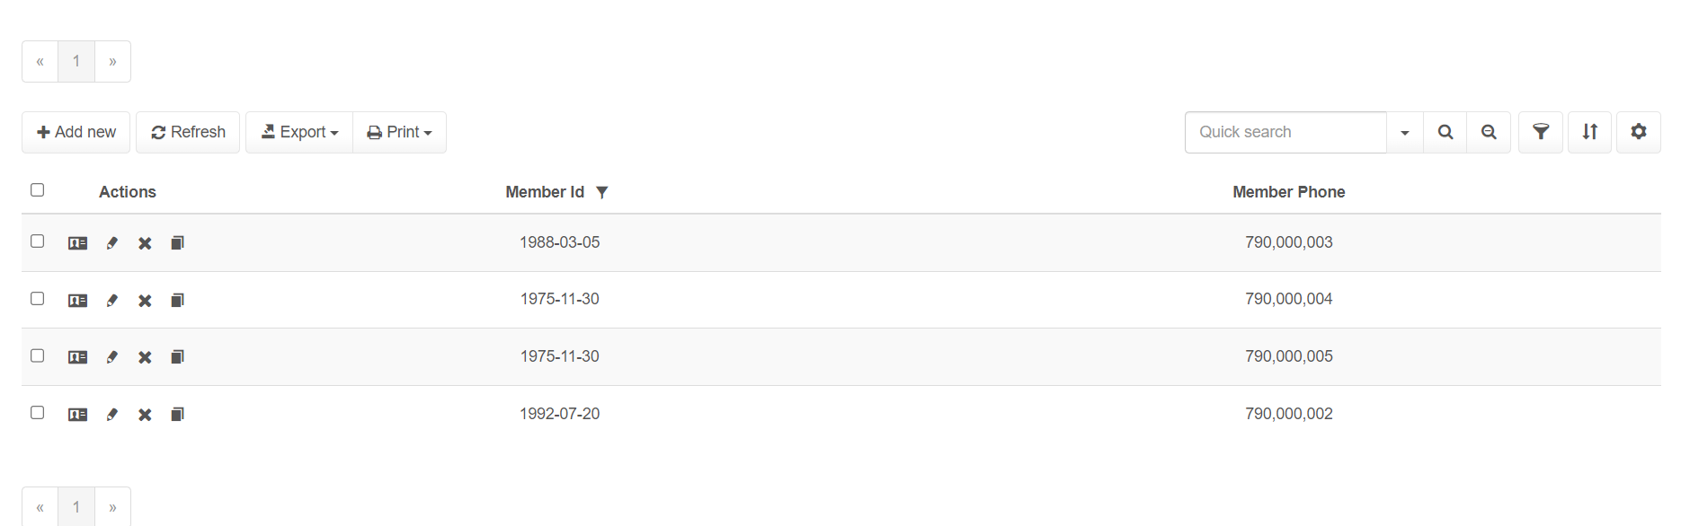

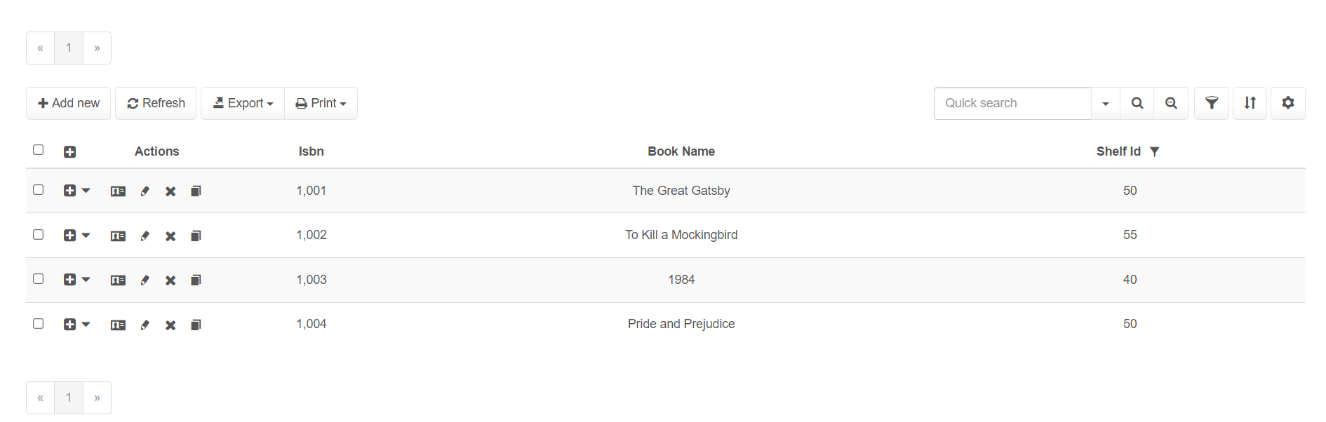

4.1

Importance of database recovery and backup:

Data Protection: Backups are essential to protect data from loss due to hardware failure, software problems, data corruption, and accidental deletion.

Disaster recovery: In the event of disasters such as fire, flood or cyber attacks, a backup allows an organization to restore its data and resume operations.

Data integrity: Regular backups help maintain data integrity by ensuring that the latest copy of data is always available in case of corruption or unwanted changes.

Compliance: Many industries have regulations requiring data backup to ensure data preservation and business continuity.

Steps for database backup:

Selecting Data for a Backup:

Select the tables or databases that require backups. This may depend on how important the data is.
Selecting the Type of Backup:

-Full Backup: provides a complete data backup.

-differential backup: Only data that has changed since the last complete backup is backed up

-Incremental Backup: Backs up data that has changed since the last any backup.

Performing the Backup:
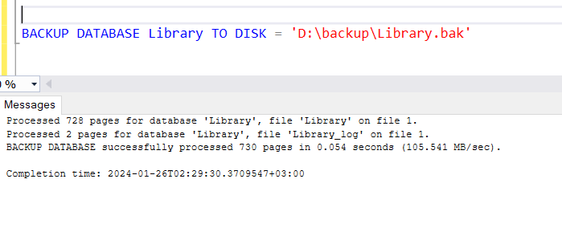

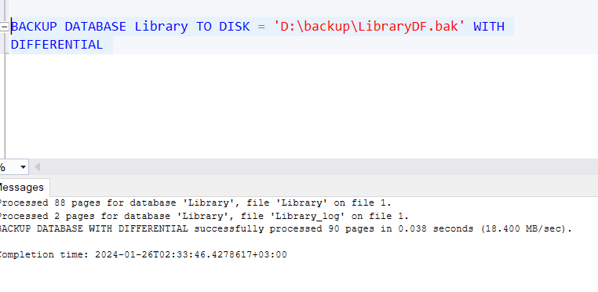

Procedure for Recovery:

Evaluation of Damage

Evaluate the level of data corruption or loss.
Selecting the Type of Recovery:

Choose between a full and partial recovery depending on the type of backup and the degree of data loss.

4.2

Database maintenance is an essential aspect of database management that guarantee optimal performance, security, and reliability of the database system.
The importance of regular maintenance cannot be put on as it directly affects the performance and efficiency of data storage and retrieval processes.
Here is an overview of its importance and the different methods used in database maintenance:
Importance of Database Maintenance: 1 .
optimization: Regular maintenance helps identify and resolve performance bottlenecks, ensuring that the database runs efficiently.
2.
Data integrity and accuracy: Maintenance tasks such as consistency checks help ensure data remains accurate and uncorrupted.
3.
security: Keeping the database system up to date through maintenance helps fix security vulnerabilities, thereby improving data security.
4.
Disaster Prevention and Recovery: Regular backup and monitoring help reduce the risk of data loss and ensure faster recovery in the event of a disaster.
5.
Compliance with standards and regulations: Proper maintenance ensures that the database complies with relevant data protection and privacy regulations.
6.
Space management: Regular cleaning helps manage storage space effectively, thereby avoiding unnecessary costs for storage resources.
Database maintenance method: 1.
Regular backup: - Perform full and incremental backups to ensure data can be restored in case of loss.
- Regularly check backup files to ensure they can be restored successfully.
2.
Update and fix database errors: - Regularly update database software to the latest version.
- Apply security patches to protect against vulnerabilities.
3.
Performance optimization: - Analyze and optimize queries for better performance.
- Indexing: Create and rebuild indexes to improve query performance.
4.
Data Validation and Consistency Checks: - Perform consistency checks to ensure data integrity.
- Validate data against predefined rules and constraints.
5.
Clean up and archive: - Filter out outdated or redundant data.
- Rarely accessed historical data archive.
6.
Monitoring and auditing: - Continuous monitoring of database performance and usage patterns.
- Audit access and modification permissions to ensure security and compliance.
7.
Defragmentation: - Defragment database files to optimize data storage and access.
- Reduce file fragmentation to improve performance.
8.
Resource Management: - Allocate and optimize the use of resources such as memory and storage.
- Ensure there are enough resources for database workloads.
9.
Disaster recovery planning: - Develop and test disaster recovery plans.
- Ensure databases can be recovered quickly after unforeseen problems.
Conclusion: Effective database maintenance involves a combination of proactive and reactive strategies designed to keep databases running smoothly and securely and efficiency.
By regularly employing these maintenance methods, organizations can ensure the long-term health and performance of their database systems, which is critical to the overall success of their operations.
their IT operations.

Testing
5.1

Data Validation

Number | Type | Description
1 | All cases of PK | I will do my test on the id PK from the library Member table  - I will try to insert two records with the same PK  - I will try to insert a record without a PK
2 | All cases of FK | I will do my tests on FK member_id from library_card table which references id attribute in Library_member table  - i will try to insert a record into library_card with a member_id that doesn’t exist in Library_member  - i will delete a record in Library_member and check if the matching record in Library_card is also deleted.  - update a primary key in Library_member and check if the corresponding foreign key in Library_card is also updated.
3 | unique | I have the member_id attribute as unique in the library_card table as it is a one to one relationship with Library_member table so i will try to add a row to library_card table with a duplicate member_id
4 | Not null | In the shelf table i have two attributes id (PK) and capacity (not null) i will try to insert a row without entering the capacity value
5 | check | In Library_member, i will attempt to insert a record with a gender value other than 'M' or 'F'.
6
7

Screenshots :
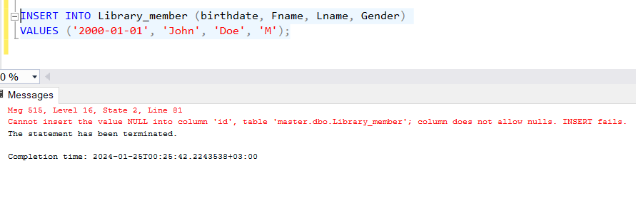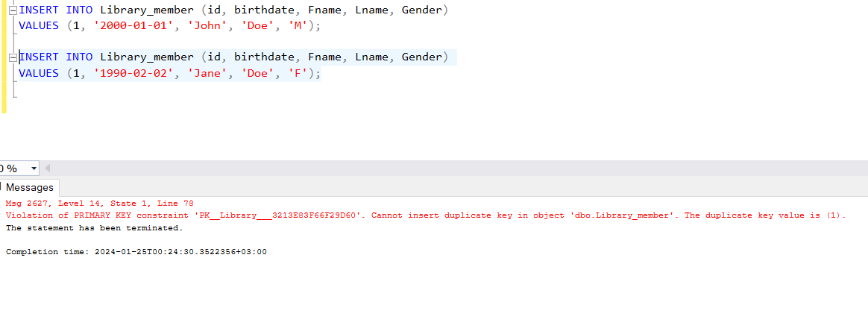

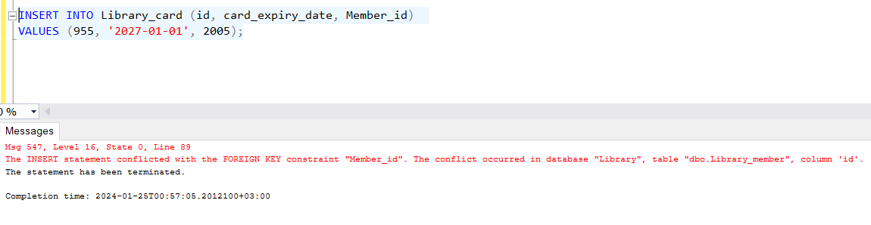

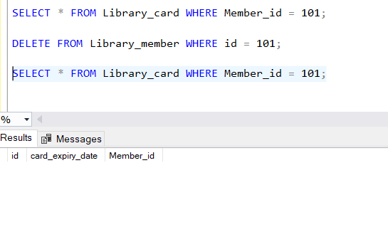
—
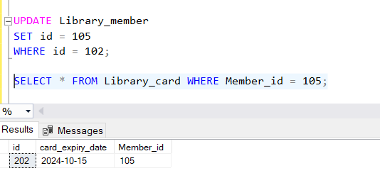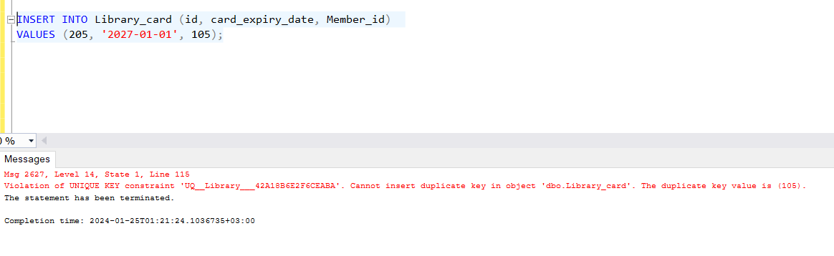

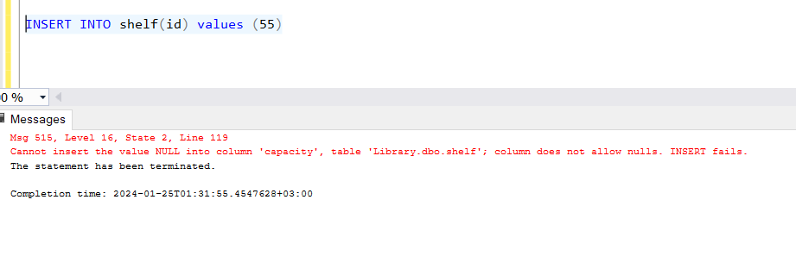
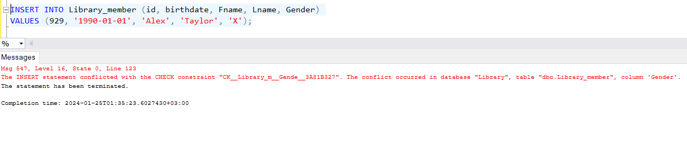

5.2
Output validation

number | Query description | Result validation
1 | get the names and birthdates of all library members who joined after a specific date ( '1990-01-01'). Using select and where | correct
2 | Add a new member to the Library_member table. Using insert | correct
3 | Update the capacty of a shelf. | correct
4 | Delete a library card that is no longer valid. | correct
5 | Count the number of books borrowed by each library member.(GROUP BY) | correct
6 | Using a view members names who have library cards | correct
7 | Using a procedure Renew a library card's expiry date | correct

Screenshots:
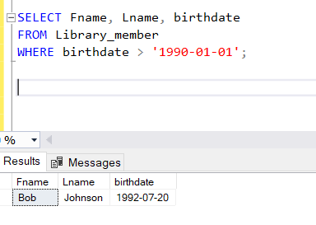

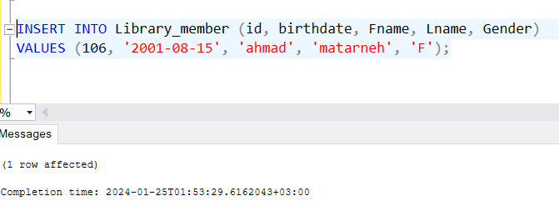

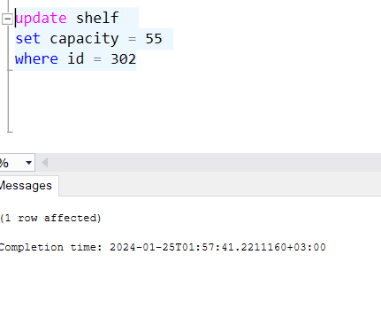
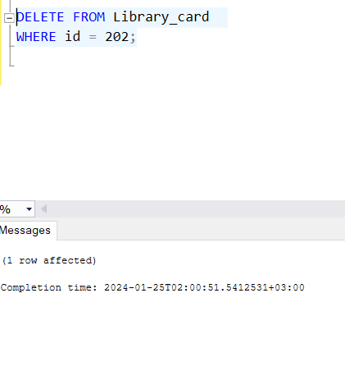

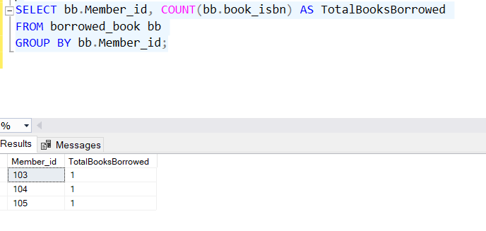

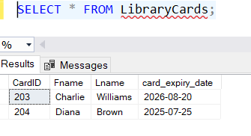

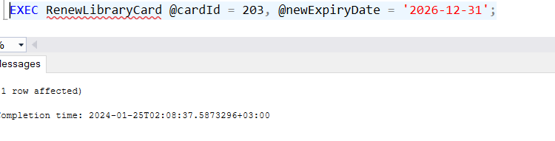

5.3

Testing of privileged commands
number | User name | Description of privilege /no privelege
1 | book_manager | As the user is the book manager they can view all the books in the database
2 | book_manager | The book manager can enter new books in the database
3 | book_manager | The book manager can update a book’s information
4 | book_manager | The book manager can delete a book from the library

Screenshots:
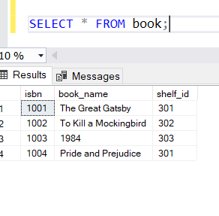

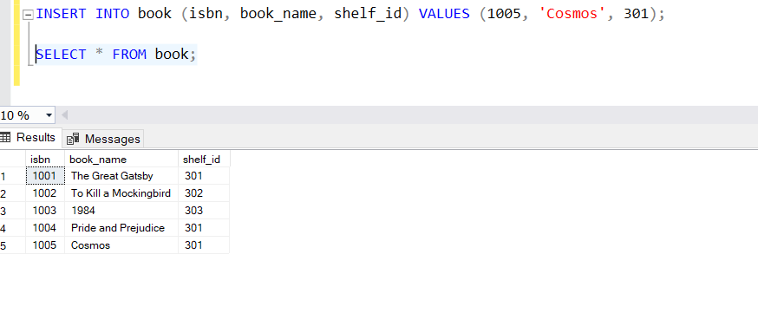

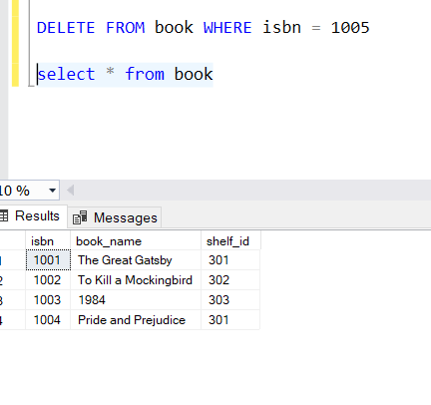

Testing for privileges not given

number | User name | Description of privilege /no privelege
1 | book_manager | Book manager can not read data from other tables(ex library_card)
2 | book_manager | Book manager can not update data into other tables(ex shelf)
3 | book_manager | Book manager can not insert data into other tables(ex library_member)
4 | book_manager | Book manager can not delete data from another table (ex library_card)

Screenshots:

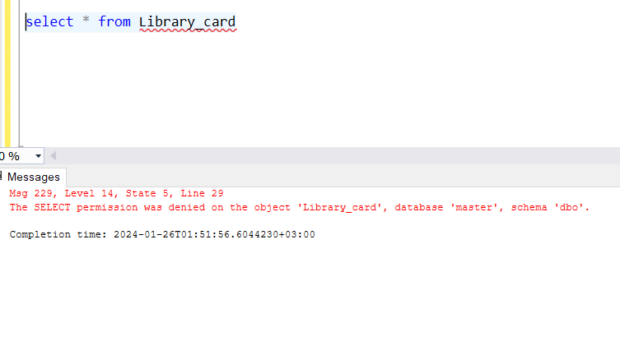
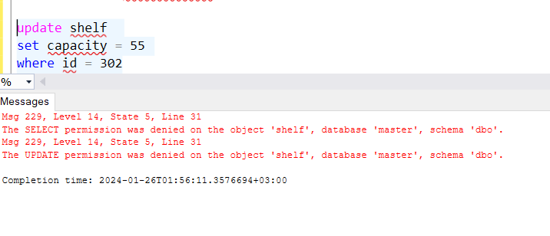

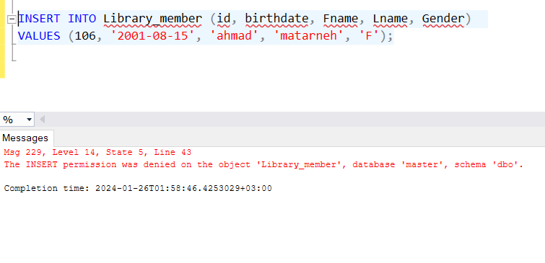
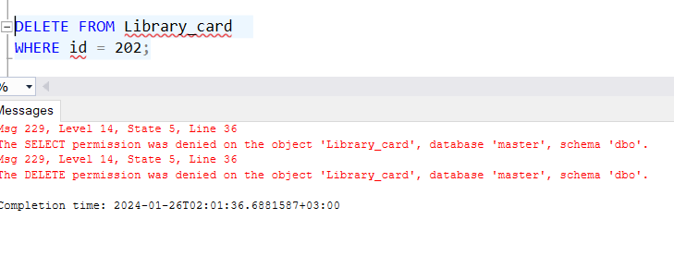

5.4

GUI validation

Number | descriptions
1 | Testing weather the tables are shown correctly:  In the borrowed book table the member id attribute is not shown correctly as it takes the member’s birthdate as the id while it should be the member id
2 | Testing inserting data from the GUI :  This was done successfully without problem as i inserted a new record into the library_member table with id = 110
3 | Updating data from the GUI :  This was done successfully without problem as I updated the first name of the member with id = 110 to ahmad
4 | Deleting data from the GUI : this was done successfully without problem as i deleted the record from library member with id = 110

Screenshots :

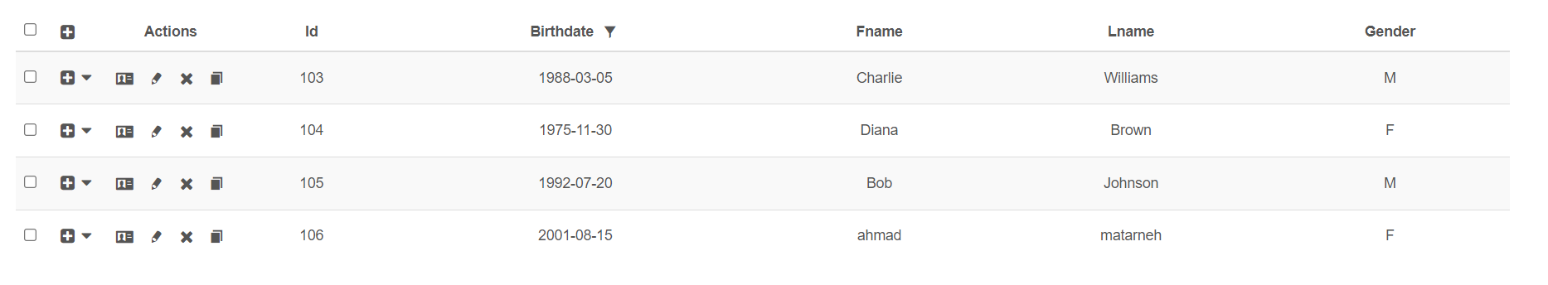

5.5
Assess whether meaningful data has been extracted

I populated my database with meaningful data which covered all cases :
-Multivalued attributes for example Member ID 104 has two phone numbers: 0790000004 and 0790000005.
- one to one relationship between library member and library card as the member id attribute is unique in library card table
One to many relationships between book and shelf as books with isbn (1001,1004) are placed on the same shelf (301)

As for many many to many relationships Library_member to Book through Borrowed_book: Members can borrow multiple books, and books can be borrowed by multiple members.

As for views and procedures :
BorrowedBooks: Shows which members have borrowed which books. Useful for tracking current book loans.
MemberContactInfo: Consolidates contact details of members. Helps in communication and member management.
LibraryCards: Details of library cards and their owners. Useful for administrative purposes.
MemberBorrowingHistory: Provides a comprehensive borrowing history for members.
The database is structured to efficiently manage a library's operations, providing benefits such as:

Easy Tracking and Management: Library staff can easily track which books are borrowed, manage member information, and keep the inventory updated.
Convenient Communication: Contact information is readily available, enabling smooth communication with members.
Efficient Organization: The ability to update book locations and renew library cards streamlines library operations

5.6
Assess the effectiveness of testing

In summary, a testing process in database development and management is essential to ensure that the database is reliable, efficient, secure, and meets the needs of users and stakeholders.

It helps identify and fix challenges before they become problems in production environments, saving time, resources, and possibly the reputation of the organization using the database.

In my testing process, i have identified where problems may occur and placed them in tables and tried to excute each test in my database system and observed and placed the results in tables

This helped me identify bugs as at first i forgot to place the on update cascade and on delete cascade for my foreign keys and i had to redo them

Also i have identified problems in my gui interfaces as the member id attribute was talen from the birthdate column and i figured out that some of the users well not well excuted

6.1
Effectiveness of the database solution based on user and system requirement

Achieving the set goal :
The main goal of the database solution is to facilitate effective library management, focusing on the interaction between library members and librarians.

This design addresses essential library operations such as borrowing books, returning books, membership registration, and account management.
Completed according to the listed requirements :

Library Member Requests:
Borrowed books: Completed via the Borrowed_book table, which records each instance of borrowing a book by members.

Return of borrowed items: Managed through the Borrowed_book table, where the return date means returning the item.

Updating personal information: The member_address and member_phone tables, as well as procedures such as AddMemberPhone and AddMemberAddress, allow updating personal information.

Renew borrowed materials: The RenewLibraryCard procedure supports library card renewal, and also by creating a new row in borrowed_book table

Librarian requirements:
Register new library member: Achieved through insert into Library_member table.

give books to library members: Manage by recording transactions in the Bored_book table.

take returned member books: Mark by updating the Borrowed_book table with the book return date.

User Account Management: The database supports account management through various tables and views, especially tracking loan history and membership details.

Unmet requirements The database includes most basic functions; However, some advanced features such as online renewals or digital notifications of due dates may not be directly supported by the current design.

Additional Requirements Incorporated
The database is designed with scalability and flexibility in mind.
For example, including more member contact information addresses more user needs beyond basic requests.

Conclusion

Overall, the database effectively fits the basic user and system requirements for a library management system.
It provides a solid foundation for key activities in borrowing, returning, and managing library resources and member information.
While it successfully meets the primary needs of library members and librarians, the system's capabilities can be further expanded with additional features to improve user interaction and efficiency.
work.
The system's current structure provides a solid basis for future improvements.

6.2
Suggested improvements

For my database the areas i would try to improve my system in :
- Addition of new attributes such as an entity for user feedback and suggestions,allowing members to rate books or leave reviews
- Also if they are digital resources in the library such as ebooks or computers i would add additional attributes for them
- As for security enhancement each library member would have their own login credentials
- Also for each staff would have their login credentials
- I would backup the data to cloud storage rather than hardrives for scalability and better security
- For business aspects i would integrate online payment methods
- For business aspects i would integrate analytical software to get more information
- I would implement a reservation system for books, allowing members to reserve books that are currently on loan.
- I would add functionalities for automated notifications and alerts for due dates, reservation availabilities, and events.

6.3

Evaluation based on improvements needed

-Adding digital resources and feedback options can significantly improve user engagement and satisfaction.
-Implementing strong security measures ensures that sensitive member and library data is protected.
-Cloud-based solutions: These changes can lead to faster query responses and accommodate a growing user base and data volume.
-Advanced analytics can provide valuable insights for better planning and library management.

Challenges:
-:
Executing these advancements, unused functionalities, may require noteworthy improvement time and exertion.
-Overhauling to cloud-based arrangements or coordination with outside frameworks might bring about extra costs and asset assignments.

- Library staff may require preparing to adjust to the modern framework functionalities, and there may be a period of alteration as they get usual to the unused forms.
- With the introduction of new functionalities like a reservation system or user feedback, there might be an increased need for ongoing maintenance and support.

Database enhancements:

-The database's execution and reaction times are anticipated to progress with legitimate ordering and cloud-based arrangements.
-Adding new entities and features will greatly improve the overall functionality of the database, making it more flexible and user-friendly.
-Advanced security features protect against data breaches and unauthorized access, building trust between users.
-The database will be better equipped to handle growing numbers of users and larger data sets, ensuring its long-term sustainability.

